Day 18 – 10th August 2026

Redirecting Output (> and >>)
> redirects normal output to a file and overwrites the existing content.
ls > files.txt
To view the content:
cat files.txt
Append Instead of Overwrite
>> redirects output to a file without deleting the existing content. It adds the new content at the end.
echo "New entry" >> files.txt
Redirecting Input (<)
The < operator is used to take input from a file and provide it to a command.
echo -e "banana\napple\ncherry" > fruits.txt
-e allows echo to interpret escape characters such as \n, which creates a new line.
Redirecting Errors (2>)
2> redirects error messages (stderr) to a file instead of displaying them on the terminal.
ls /not_a_real_folder 2> errors.txt
Here, 2 represents standard error (stderr), and errors.txt stores the error message.

Filter processes

ps aux | grep bash

Check with
Ps a → Shows processes running on the current terminal and other terminals.
Ps au → Shows detailed information about processes running for all users, including CPU and memory usage.
Ps aux → Shows detailed information about all running processes on the system.

Ps aux | grep bash → Shows all running processes and filters the output to display only processes containing bash.

| (pipe) → Sends the output of ps aux as input to grep bash.
grep bash → Searches for and displays lines containing the word bash.

du -sh * | sort -rh | head -5

mnt/c/Linux_folder$ du -sh * | sort -rh | head -5
4.0K errors.txt
0 fruits.txt
0 file1.txt
0 file.txt

Multi-stage Pipeline

Du -sh * → Shows the size of each file and folder in the current directory in a human-readable format.

du -sh * | sort -rh → Gets the sizes and sorts them from largest to smallest.
- sort → sorts the output.
- -r → reverse order.
- -h → understands human-readable sizes such as K, M, and G.

du -sh * | sort -rh | head -5 → Gets the sizes, sorts them from largest to smallest, and displays only the top 5 largest files/folders.

du -sh * | sort | head -5 → Gets the sizes, sorts them using normal alphabetical/text sorting, and displays the first 5 lines.

./script.sh >/dev/null 2>&1
./script.sh
→ Executes the script.sh file from the current directory.
>/dev/null
→ Redirects normal output (stdout) to /dev/null, so it is discarded.
2>&1
→ Redirects error output (stderr) to the same place as stdout (/dev/null).

Silent Execution will Suppress output

./script.sh > /dev/null 2>&1

Task 1: Sed
What is sed?
sed stands for Stream Editor. It is a Linux command used to search, replace, delete, and print specific lines from text files.
Create a file named:
filename.txt
Add some dummy text to the file for practicing the following commands.
1. Display the contents of a file
sed filename.txt
→ This is not the correct syntax for simply displaying a file because sed requires an editing command.
To display the contents of the file, use:
cat filename.txt
2. Replace a word with another word
sed 's/old/new/' filename.txt
→ Searches for the first occurrence of old on each line and replaces it with new.
- s → Substitute
- old → Word to search for
- new → Replacement word
- filename.txt → File to process
Example:
sed 's/lorem/python/' filename.txt
3. Replace all occurrences using the g flag
sed 's/old/new/g' filename.txt
→ Replaces all occurrences of old with new on each line.
- g → Global, meaning all matching occurrences are replaced.
Example:
sed 's/lorem/python/g' filename.txt
4. Delete lines using the d flag
sed '/word/d' filename.txt
→ Deletes every line containing the specified word from the output.
- d → Delete
Example:
sed '/lorem/d' filename.txt
This displays the file without the lines containing lorem.
5. Print a specific line
To print line 3 of the file:
sed -n '3p' filename.txt
→ Prints only line 3.
- -n → Suppresses the default output.
- 3 → Specifies line number 3.
- p → Print the selected line.
6. Print a range of lines
To print lines 2 through 5:
sed -n '2,5p' filename.txt
→ Prints only lines 2, 3, 4, and 5.
- 2,5 → Specifies the range from line 2 to line 5.
- p → Prints those lines.
- -n → Prevents other lines from being displayed.

Task 2: Awk
What is awk?
awk is a Linux command used for pattern scanning and text processing. It is especially useful for reading structured text and working with columns or fields.
Create or use a file named:
filename.txt
For example, the file may contain:
John 25 Bangalore
David 30 Mumbai
Alex 28 Chennai
1. Display the contents of the file
awk '{print}' filename.txt
→ Prints the entire contents of the file.
- awk → Starts the AWK command.
- {print} → Prints each complete line.
- filename.txt → File to process.
2. Print a specific column
awk '{print $2}' filename.txt
→ Prints only the second column of each line.
Example:
John 25 Bangalore
David 30 Mumbai
Alex 28 Chennai
Output:
25
30
28
- $1 → First column
- $2 → Second column
- $3 → Third column
3. Print multiple columns
awk '{print $1, $3}' filename.txt
→ Prints the first and third columns of each line.
Output:
John Bangalore
David Mumbai
Alex Chennai
Here:
- $1 → First column
- $3 → Third column
- , → Adds a space between the printed columns.

4. Filter rows using a condition
To print the 1st and 3rd columns only when the value in the 3rd column is greater than 50:
awk '$3 > 50 {print $1, $3}' filename
→ Checks whether the value in the 3rd column is greater than 50. If the condition is true, it prints the 1st and 3rd columns.
- $3 > 50 → Condition
- $1 → First column
- $3 → Third column
5. Use a custom delimiter
If the fields in the file are separated by a comma (,), use -F, to specify the comma as the field separator.
awk -F, '{print $1, $2}' filename
→ Uses the comma as the delimiter and prints the first two fields.
- -F, → Sets comma as the field separator.
- $1 → First field.
- $2 → Second field.
For example, if the file contains:
John,25,Bangalore
David,30,Mumbai
Alex,28,Chennai
The output will be:
John 25
David 30
Alex 28
6. Count the number of lines
awk 'END {print NR}' filename
→ Prints the total number of lines (records) in the file.
- NR → Number of records (lines) processed.
- END → Runs after all lines have been processed.
- print NR → Prints the final value of NR, which gives the total number of lines.

Task 3:
Ping google.com
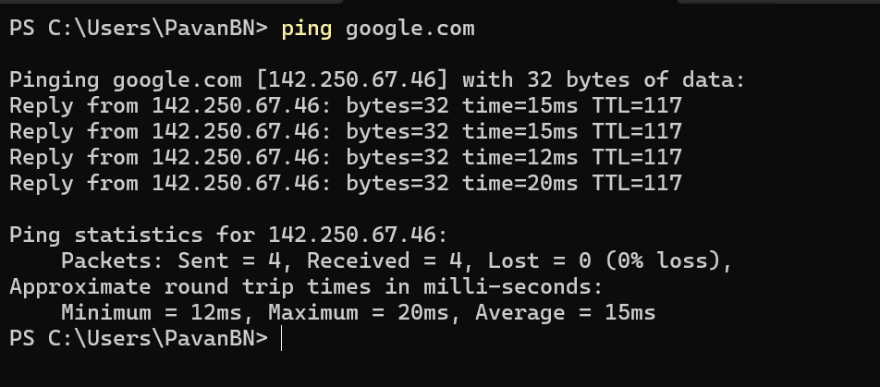

Curl:
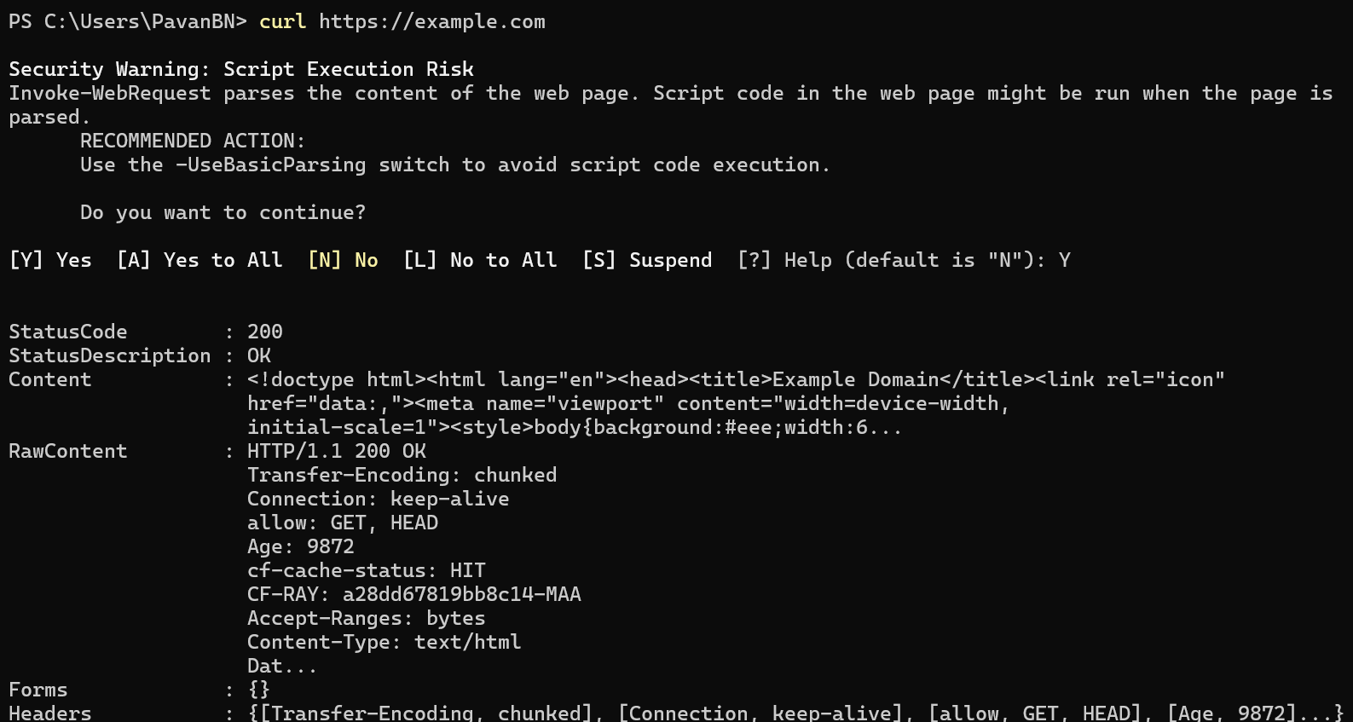

Task 4:
Install open ssl in your system

https://www.xolphin.com/support/OpenSSL/OpenSSL_-_Installation_under_Windows#:~:text=Download%20the%20OpenSSL%20for%20Windows,file%20can%20be%20downloaded%20here.

Or

https://slproweb.com/products/Win32OpenSSL.html

Step 2 Generate a certificate signing request (CSR)
openssl genrsa -out localhost.key 2048
Step 3:

Generate a self-signed certificate
In bash
openssl x509 -req -days 365 -in localhost.csr -signkey localhost.key -out localhost.crt

Step 4:

Now Start a Simple HTTPS Server
Use Python: `python -m http.server 4443 --bind 127.0.0.1 --ssl-certfile cert.pem --ssl-keyfile key.pem`.

Step 5:
Now Test with Browser or Curl
Visit https://localhost:4443 or run `curl -k https://localhost:4443` to see encrypted communication.

Step 6:

Did u Observe TLS Handshake
Use Wireshark or `openssl s_client -connect localhost:4443` to watch how TLS negotiates keys and ciphers.

Step 7:

Verify Certificate Trust
Browsers will warn about self-signed certs; in real deployments, use CA-issued certificates for trust.

Task 5:
What are trees ? where do you implement them?
A tree is a non-linear data structure that organizes data in a hierarchical structure using nodes and edges.
Each tree has a root node, and nodes can have child nodes. A tree does not contain cycles.
Where are Trees Implemented?
Trees are commonly used in:
- File systems → Folders and files are organized hierarchically.
- Databases → B-Trees and B+ Trees are used for indexing.
- HTML/XML DOM → Web pages are represented as a tree of elements.
- Searching → Binary Search Trees help organize data for efficient searching.
- Compilers → Abstract Syntax Trees (ASTs) represent program structure.
- Artificial Intelligence → Decision trees are used for decision-making.
- Networking → Routing and hierarchical network structures.

Task 6:
Can you give types of trees?
- Binary Tree → Each node can have at most two children.
- Binary Search Tree (BST) → Left child contains smaller values and right child contains larger values.
- AVL Tree → A self-balancing Binary Search Tree.
- Red-Black Tree → A self-balancing binary search tree using color properties.
- Heap → A complete binary tree commonly used for priority queues.
- B-Tree → A balanced tree commonly used in databases and file systems.
- B+ Tree → A variation of B-Tree widely used for database indexing.
- Trie → A tree used for storing and searching strings efficiently.
- N-ary Tree → A node can have more than two children.
- Decision Tree → Used in machine learning for making decisions based on conditions.

Task 7:
What is binary search tree?

A Binary Search Tree (BST) is a binary tree where each node has smaller values on the left side and larger values on the right side. This makes searching, inserting, and deleting elements faster. On average, these operations take O(log n) time when the tree is balanced.

Task 8:
Can you create a simple binary tree using a node and insert values in it?
Like in java

class Node {
int val;
Node left, right;
Node(int val) { this.val = val; }
}

Insert values in left side and right side of the nodes and display the tree values
class Node {
int val;
Node left, right;

Node(int val) {
this.val = val;
}
}

public class BinaryTree {

static Node insert(Node root, int val) {
if (root == null) {
return new Node(val);
}

if (val < root.val) {
root.left = insert(root.left, val);
} else {
root.right = insert(root.right, val);
}

return root;
}

static void display(Node root) {
if (root != null) {
display(root.left);
System.out.print(root.val + " ");
display(root.right);
}
}

public static void main(String[] args) {
Node root = null;

root = insert(root, 50);
insert(root, 30);
insert(root, 70);
insert(root, 20);
insert(root, 40);

System.out.println("Tree values:");
display(root);
}
}

Task 9
Now extend the above code to search a no in your list.
class Node {
int val;
Node left, right;

Node(int val) {
this.val = val;
}
}

public class BinaryTree {

static Node insert(Node root, int val) {
if (root == null) {
return new Node(val);
}

if (val < root.val)
root.left = insert(root.left, val);
else
root.right = insert(root.right, val);

return root;
}

static boolean search(Node root, int val) {
if (root == null)
return false;

if (root.val == val)
return true;

if (val < root.val)
return search(root.left, val);
else
return search(root.right, val);
}

public static void main(String[] args) {
Node root = null;

root = insert(root, 50);
insert(root, 30);
insert(root, 70);
insert(root, 20);
insert(root, 40);

int value = 40;

if (search(root, value))
System.out.println(value + " found in the tree");
else
System.out.println(value + " not found in the tree");
}
}

Task 10:
Now can you do inorder traversal in your bst?
class Node {
int val;
Node left, right;

Node(int val) {
this.val = val;
}
}

public class BinaryTree {

static Node insert(Node root, int val) {
if (root == null) {
return new Node(val);
}

if (val < root.val)
root.left = insert(root.left, val);
else
root.right = insert(root.right, val);

return root;
}

static boolean search(Node root, int val) {
if (root == null)
return false;

if (root.val == val)
return true;

if (val < root.val)
return search(root.left, val);
else
return search(root.right, val);
}

public static void main(String[] args) {
Node root = null;

root = insert(root, 50);
insert(root, 30);
insert(root, 70);
insert(root, 20);
insert(root, 40);

int value = 40;

if (search(root, value))
System.out.println(value + " found in the tree");
else
System.out.println(value + " not found in the tree");
}
}

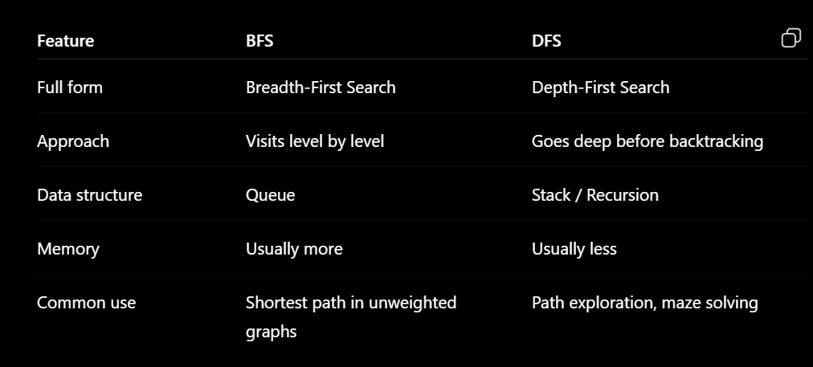

task 12:
Which underlying data structures are used to implement BFS and DFS?
3.01 to 3.05
BFS uses a Queue data structure because it follows FIFO (First In, First Out). DFS uses a Stack data structure because it follows LIFO (Last In, First Out). DFS can also be implemented using recursion.

Task 13:
How do you find the shortest path in an unweighted graph?
To find the shortest path in an unweighted graph, we use BFS (Breadth-First Search). BFS visits nodes level by level, so the first time we reach the destination node, we have found the shortest path in terms of the number of edges.

task 14:
How do you detect a cycle in a graph?
To detect a cycle in a graph, we can use DFS (Depth-First Search). During traversal, if we reach a node that has already been visited and is part of the current traversal path, then a cycle exists. For an undirected graph, we also keep track of the parent node to avoid treating the same edge as a cycle.

import java.util.*;

public class CycleDetection {

static boolean hasCycle(int node, int parent,
List<List<Integer>> graph,
boolean[] visited) {

visited[node] = true;

for (int neighbor : graph.get(node)) {

if (!visited[neighbor]) {
if (hasCycle(neighbor, node, graph, visited))
return true;
}
else if (neighbor != parent) {
return true;
}
}

return false;
}

public static void main(String[] args) {

int n = 4;
List<List<Integer>> graph = new ArrayList<>();

for (int i = 0; i < n; i++)
graph.add(new ArrayList<>());

graph.get(0).add(1);
graph.get(1).add(0);

graph.get(1).add(2);
graph.get(2).add(1);

graph.get(2).add(0);
graph.get(0).add(2);

boolean[] visited = new boolean[n];

System.out.println(
hasCycle(0, -1, graph, visited)
? "Cycle exists"
: "No cycle"
);
}
}

task 15:
Explain the internal working of a HashMap.

A HashMap stores data in key-value pairs using a hashing technique.
- The key's hashCode() is calculated.
- The hash is used to determine the bucket/index where the entry is stored.
- If multiple keys map to the same bucket, a collision occurs.
- Collisions are handled using a linked list or balanced tree (in Java 8+).
- When retrieving a value, equals() is used to find the exact key within the bucket.
- When the number of entries becomes too large, the HashMap resizes its internal array.
Average time complexity: O(1) for put() and get().

Task 16:
Which property of a hashmap is used to find the intersection of two arrays?
The key uniqueness property of a HashMap is used to find the intersection of two arrays.
- Store elements of the first array as keys.
- Check whether elements of the second array exist as keys.
- If they exist, they are part of the intersection.
Key property: Fast key lookup — average O(1) time.

Task 17:
What is collision in HashMap?
A collision occurs when two or more different keys produce the same hash/index and are mapped to the same bucket.
Example:
Key A → Bucket 3
Key B → Bucket 3
HashMap handles collisions using linked lists or balanced trees.

Task 18:
How Does Java's Capacity And Size Of Hashmap Differ?
Term | Meaning
Capacity | Number of buckets available in the HashMap.
Size | Number of key-value pairs currently stored.

Task 19:
Does hashmap allow you to store null values?
Yes, We can store as many null values in a hashmap as we want but only one null key can be stored not more than that.

Let’s see a program that depicts how we can store null values in a hashmap.

import java.util.*;
import java.io.*;
public class interviewBit {
public static void main(String[] args)
{
HashMap hmap=new HashMap();
hmap.put(1,"Program to store null value");
hmap.put(null,"InterviewBit");
System.out.println(hmap);
}
}

Can you predict the output and also explain.. I or 2 lines

{null=InterviewBit, 1=Program to store null value}
Explanation: A HashMap allows one null key and multiple null values. Here, null is used as a key, so it stores null=InterviewBit.

Task 20:
hashmaps in Java are not thread-safe.can you juztify?
Java HashMap is not thread-safe because multiple threads can modify it simultaneously, which may cause data inconsistency or race conditions.
For thread-safe operations, use ConcurrentHashMap.

Task 21:
Can you store multiple keys with the same value in a hashmap?
Yes. A HashMap allows multiple different keys to have the same value, but keys must be unique.
Example: A → 10, B → 10 is valid.

Task 22:
can you tell the differences between a Hashmap and a Hashtable in Java.

HashMap | Hashtable
Not thread-safe | Thread-safe
Allows one null key and multiple null values | Does not allow null keys or values
Faster | Slower due to synchronization
Introduced in Java 1.2 | Legacy class from Java 1.0

Sorting Algorithms
Task 23:
Can you create a java code for bubble sort …

The snippet for your ref is given below

1. Bubble Sort
- Concept: Repeatedly swaps adjacent elements if they are in the wrong order.
- Complexity: O(n2)
- Best for: Small datasets or teaching algorithm basics.
java
for (int i = 0; i < n-1; i++)
for (int j = 0; j < n-i-1; j++)
if (arr[j] > arr[j+1])
swap(arr[j], arr[j+1]);

Visualization: Each pass “bubbles” the largest element to the end.
public class BubbleSort {
public static void main(String[] args) {
int[] arr = {5, 3, 8, 4, 2};
int n = arr.length;

for (int i = 0; i < n - 1; i++) {
for (int j = 0; j < n - i - 1; j++) {
if (arr[j] > arr[j + 1]) {
int temp = arr[j];
arr[j] = arr[j + 1];
arr[j + 1] = temp;
}
}
}

System.out.println("Sorted array:");
for (int num : arr) {
System.out.print(num + " ");
}
}
}

2. Selection Sort
- Concept: Selects the smallest element and places it at the beginning.
- Complexity: O(n2)
- Best for: Simple, predictable sorting.
java
for (int i = 0; i < n-1; i++) {
int min = i;
for (int j = i+1; j < n; j++)
if (arr[j] < arr[min]) min = j;
swap(arr[i], arr[min]);
}
public class SelectionSort {
public static void main(String[] args) {
int[] arr = {5, 3, 8, 4, 2};
int n = arr.length;

for (int i = 0; i < n - 1; i++) {
int min = i;

for (int j = i + 1; j < n; j++) {
if (arr[j] < arr[min]) {
min = j;
}
}

int temp = arr[i];
arr[i] = arr[min];
arr[min] = temp;
}

for (int num : arr) {
System.out.print(num + " ");
}
}
}

Searching Algorithms
Can you create a java code for linear search …

The snippet for your ref is given below

1. Linear Search
- Concept: Sequentially checks each element.
- Complexity: O(n)
- Best for: Unsorted or small datasets.
java
for (int i = 0; i < n; i++)
if (arr[i] == key) return i;
public class LinearSearch {
public static void main(String[] args) {
int[] arr = {10, 20, 30, 40, 50};
int key = 30;

int result = -1;

for (int i = 0; i < arr.length; i++) {
if (arr[i] == key) {
result = i;
break;
}
}

if (result != -1)
System.out.println("Element found at index: " + result);
else
System.out.println("Element not found");
}
}
Home tasks:
Can you create a java code for earch of the below sort and search …

The snippet for your ref is given below
3. Insertion Sort
- Concept: Builds the sorted array one element at a time.
- Complexity: O(n2)
- Best for: Nearly sorted data.
java
for (int i = 1; i < n; i++) {
int key = arr[i];
int j = i - 1;
while (j >= 0 && arr[j] > key)
arr[j+1] = arr[j--];
arr[j+1] = key;
}
public class InsertionSort {
public static void main(String[] args) {
int[] arr = {5, 3, 8, 4, 2};

for (int i = 1; i < arr.length; i++) {
int key = arr[i];
int j = i - 1;

while (j >= 0 && arr[j] > key) {
arr[j + 1] = arr[j];
j--;
}

arr[j + 1] = key;
}

System.out.println("Sorted array:");
for (int num : arr) {
System.out.print(num + " ");
}
}
}
4. Merge Sort
- Concept: Divide and conquer — splits array, sorts halves, merges results.
- Complexity: O(nlog⁡n)
- Best for: Large datasets.
java
void mergeSort(int[] arr, int l, int r) {
if (l < r) {
int m = (l + r) / 2;
mergeSort(arr, l, m);
mergeSort(arr, m+1, r);
merge(arr, l, m, r);
}
}

public class MergeSort {

static void mergeSort(int[] arr, int l, int r) {
if (l < r) {
int m = (l + r) / 2;

mergeSort(arr, l, m);
mergeSort(arr, m + 1, r);

merge(arr, l, m, r);
}
}

static void merge(int[] arr, int l, int m, int r) {
int[] temp = new int[r - l + 1];

int i = l, j = m + 1, k = 0;

while (i <= m && j <= r) {
if (arr[i] <= arr[j])
temp[k++] = arr[i++];
else
temp[k++] = arr[j++];
}

while (i <= m)
temp[k++] = arr[i++];

while (j <= r)
temp[k++] = arr[j++];

for (i = 0; i < temp.length; i++)
arr[l + i] = temp[i];
}

public static void main(String[] args) {
int[] arr = {5, 3, 8, 4, 2};

mergeSort(arr, 0, arr.length - 1);

System.out.println("Sorted array:");
for (int num : arr)
System.out.print(num + " ");
}
}

5. Quick Sort
- Concept: Selects a pivot, partitions array around it.
- Complexity: Average O(nlog⁡n), Worst O(n2)
- Best for: Fast in practice, widely used.
java
int partition(int[] arr, int low, int high) {
int pivot = arr[high];
int i = low - 1;
for (int j = low; j < high; j++)
if (arr[j] < pivot) swap(arr[++i], arr[j]);
swap(arr[i+1], arr[high]);
return i+1;
}

Search
public class QuickSort {

static void quickSort(int[] arr, int low, int high) {
if (low < high) {
int p = partition(arr, low, high);

quickSort(arr, low, p - 1);
quickSort(arr, p + 1, high);
}
}

static int partition(int[] arr, int low, int high) {
int pivot = arr[high];
int i = low - 1;

for (int j = low; j < high; j++) {
if (arr[j] < pivot) {
i++;

int temp = arr[i];
arr[i] = arr[j];
arr[j] = temp;
}
}

int temp = arr[i + 1];
arr[i + 1] = arr[high];
arr[high] = temp;

return i + 1;
}

public static void main(String[] args) {
int[] arr = {5, 3, 8, 4, 2};

quickSort(arr, 0, arr.length - 1);

System.out.println("Sorted array:");
for (int num : arr)
System.out.print(num + " ");
}
}

2. Binary Search
- Concept: Repeatedly divides sorted array in half.
- Complexity: O(log⁡n)
- Best for: Sorted data.
java
int binarySearch(int[] arr, int key) {
int low = 0, high = arr.length - 1;
while (low <= high) {
int mid = (low + high) / 2;
if (arr[mid] == key) return mid;
if (arr[mid] < key) low = mid + 1;
else high = mid - 1;
}
return -1;
}

public class BinarySearch {

static int binarySearch(int[] arr, int key) {
int low = 0;
int high = arr.length - 1;

while (low <= high) {
int mid = low + (high - low) / 2;

if (arr[mid] == key)
return mid;

if (arr[mid] < key)
low = mid + 1;
else
high = mid - 1;
}

return -1;
}

public static void main(String[] args) {
int[] arr = {10, 20, 30, 40, 50};
int key = 30;

int result = binarySearch(arr, key);

if (result != -1)
System.out.println("Element found at index: " + result);
else
System.out.println("Element not found");
}
}

